- THE ROTARY ENGINE
Advantages of the rotary engines
- It has a compact design
- Low weight
- Has higher power output than that of a four stroke reciprocating engine of similar engine displacement.
- Not prone to engine knock
- No reciprocating parts
- Uses fuels of wider octane rating
- It is cheaper for mass production because the engine contains fewer moving parts.
- Absence of reciprocating parts permits high engine speeds.
- Engine balancing and vibration problem more easily overcomed.
- Breathing and volumetric efficiency are improved.
- Little maintenance required due to simple construction.
- Low engine noise caused by absence of reciprocating components.
S.I ROTARY ENGINE (WANKEL ENGINE)
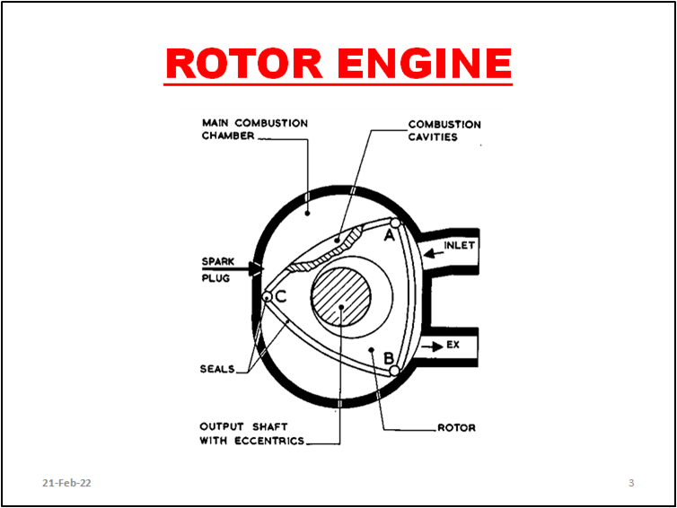
OPERATION
INDUCTION: Chamber AB formed between main chamber walls and rotor corners A and B is at its minimum volume. As rotor is turned anti-clockwise the volume is increased and resulting pressure difference forces petrol and air mixture flow from carb to fill the chamber. As B passes inlet port upper side this chamber induction operation is completed and that for chamber BC commences.
COMPRESSION: Continued rotor turning results in volume of chamber AB reduced and mixture compressed about ⅟9 of its original volume. At the same time chamber BC is nearing completion of its induction operation.
POWER: As centre of side A-B of rotor passes the two spark plugs compressed mixture is ignited, the resulting expansion forces rotor to turn and rotate output shaft via shaft eccentric. While gases are burning in AB, Induction of chamber BC is completed and its compression operation commenced.
EXHAUST: As rotor turns under pressure of expanding gases corner A opens exhaust port and gases begin to leave chamber under their own pressure. Further rotation reduces volume of chamber, the remaining gases are forced out, and operating cycle of this chamber started again as corner B passes upper edge of exhaust port.
During expansion and exhausting of gases in AB gases in BC have been ignited and begun expansion. At same time CA has almost completed its induction operation.

- GAS TURBINE ENGINE
Principles of Gas Turbine
The general assembly is housed in one long tube.
At the front of this tube is a starter motor which drives the compressor turbine by starting the engine. The compressor is connected to compressor turbine by means of a long shaft. A power turbine is situated after the compressor turbine and a shaft extends outside the casing to drive the transmission. The burnt gas is deflected through a heat exchanger to the exhaust pipe. A continous flow fuel system injects fuel into combustion chamber which is situated between the compressor and the compressor turbine.

Operation
To start the engine the starter motor is activated which drives the compressor which draws in air and pumps it into the combustion chamber. At this moment the fuel begins to flow and the ignitor is operated and the combustion begins, the gas rapidly expands and strikes the vanes of the compressor turbine which in turn drives the compressor. The gas then passes on to the power turbine which drives the transmission and is then directed into the heat exchanger and the exhaust system.
Advantages of Gas turbine engines
- The construction is simple.
- There is no vibration.
- There is no mechanical noise.
- Light in weight.
- Cheap to produce.
- Has long life.
- Requires no cooling system.
- Low oil consumption.
- Uses low grade fuel.
Disadvantages of Gas turbine engines.
- Slow in responding to drivers speed reduction.
- Requires high gear reduction.
- Engine brake not possible.
- Heavy fuel consumption.
- Delayed response to accelerator control.

